C:\Users\admin\AppData\Local\Microsoft\Windows\Temporary Internet Files\Content.IE5\4S1LQT5Q\blue-2024619_960_720[1].pngC:\Users\admin\AppData\Local\Microsoft\Windows\Temporary Internet Files\Content.IE5\FW1EVQ8D\gps_PNG50[1].pngp

**Elsa Abernathsy**

**Miss Talia Corkery DDS**

134 Daisy St. Brgy. Lingga Calamba City, 4027

123-88-999

student@yahoo.com

**WORK EXPERIENCE**

Employer Name Job Title

My job is to do my job

Salary: $ 10

Commission: $ 1000

**EDUCATION**

**SKILLS**

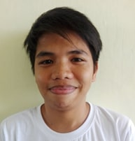

**ABOUT ME**

I am Elsa Abernathsy Miss Talia Corkery DDS

**WEBSITES & SOCIAL LINKS**

student@yahoo.com

**LANGUAGES**